ESP32 MESH User Guide

  - February 2021
  - Version 1.0

Table of Contents
1. Introduction 1
1.1 Scope and Purpose 1
1.2 Process Overview 1
2. Pre-Requisites 2
3. ESP32 Mesh Setup and Operation 3
3.1 Upload Codes onto ESP32 3
3.2 Take a Picture using the ESP32-CAM and send to the Raspberry Pi 4
4. References and Additional Reading Materials 6

Introduction

Scope and Purpose
This document serves to detail the steps to set up the ESP32 boards for the Mesh Network and Base64 encoding.

Process Overview
- The manufacturing machine starts up and its LED screen displays the cycle time
- An ESP32-CAM takes a picture of the machine's display
- The ESP32-CAM encodes the image into Base64 format, converting it into a sequence of letters and numbers before transmitting it to a Raspberry Pi through the Mesh Network containing multiple ESP32s
- The ESP32s in the Mesh Network forwards the Base64 towards the Raspberry Pi
- The Raspberry Pi receives and decodes the Base64, converting it back to an image. It will then feed the image into an Optical Character Recognition (OCR) program that converts the cycle time from the image into text
- This information can be uploaded to a database for post-processing and fed into a Machine Learning program to predict when the machine is due for servicing.
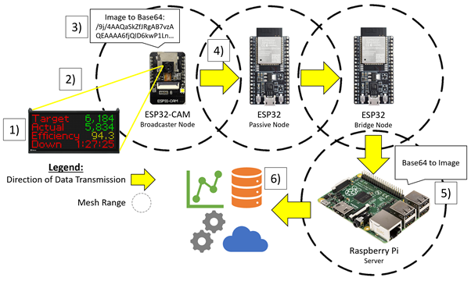

Pre-Requisites
A laptop should be installed with Arduino IDE and the software drivers for ESP32. Please refer to the installation guide provided by Dr Yap or Mr Mark. You should also minimally have 1 ESP32-CAM, 2 ESP32 and 1 Raspberry Pi as shown in the diagram above.

Arduino IDE should contain the PainlessMesh software library, please refer the following website for the steps to download it under “Installing painlessMesh Library”
https://randomnerdtutorials.com/esp-mesh-esp32-esp8266-painlessmesh/

PainlessMeshBoost must be installed on the Raspberry Pi as it will be used to communicate with the Mesh Network. The following commands will install PainlessMeshBoost on the Raspberry Pi.

git clone --recurse-submodules https://gitlab.com/painlessMesh/painlessmeshboost.git
cd painlessmeshboost
cmake .
make
sudo make install
Please refer to the following website for a detailed explanation on PainlessMeshBoost:
https://gitlab.com/painlessMesh/painlessmeshboost

You should also download the Python script onto the Raspberry Pi from /Project Files/ESP32 Mesh/Raspberry Pi Python Script as it will be used to decode the Base64 and save it as an image on the filesystem.

ESP32 Mesh Setup and Operation

Upload Codes onto ESP32
Step 1: Download the ESP32 codes from /Project Files/ESP32 Mesh/Arduino IDE. There are 3 sets of codes for the ESP32-CAM, ESP32 Passive Node and ESP32 Bridge Node respectively.

Step 2: Double-click on the codes to open them in Arduino IDE.

Step 3: Connect an ESP32 to the laptop using a USB connection and select the respective Board Name and COM Port on Arduino IDE as shown below. Please select the respective Board Name accordingly.
ESP32: ESP32 Dev Module
ESP32-CAM: AI-Thinker ESP32-CAM

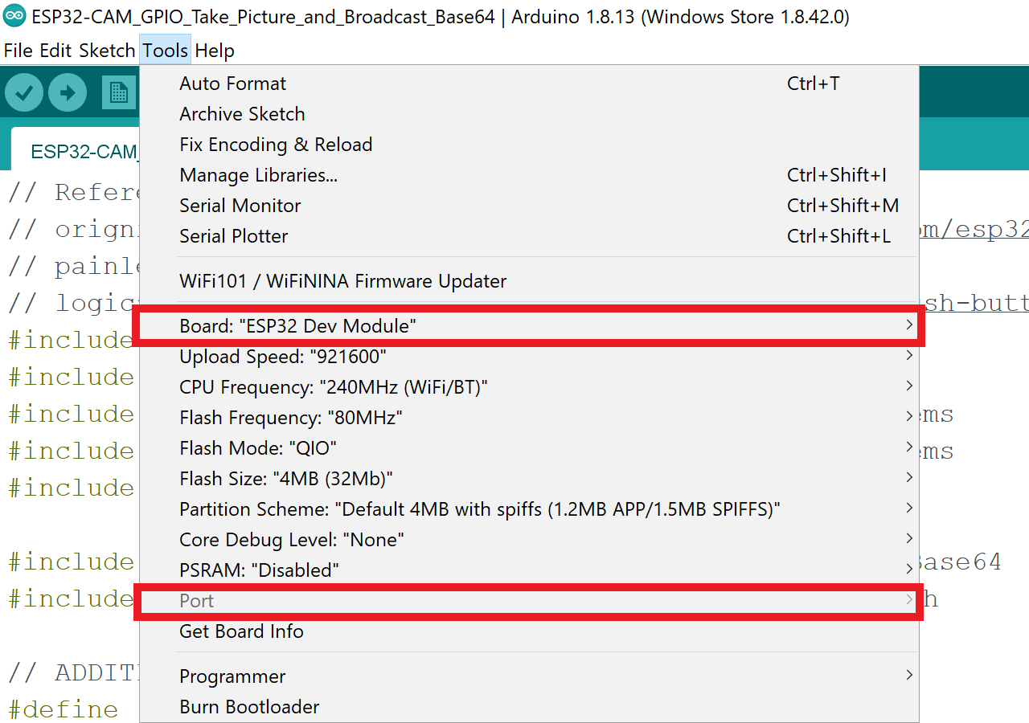

When uploading the code onto ESP32, you must hold down the “Boot” button as shown below during this process in order for Arduino IDE to successfully upload the code.
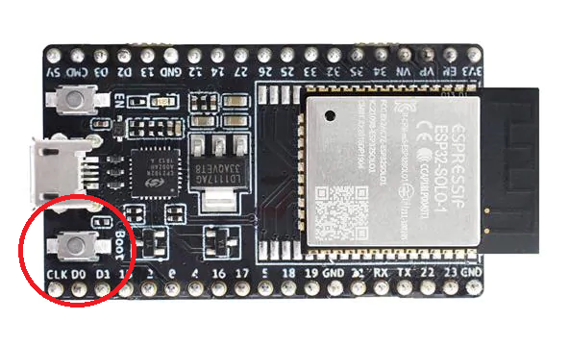
As for the ESP32-CAM, a jumper wire must be used to connect GPIO 0 to ground as shown in the image below.
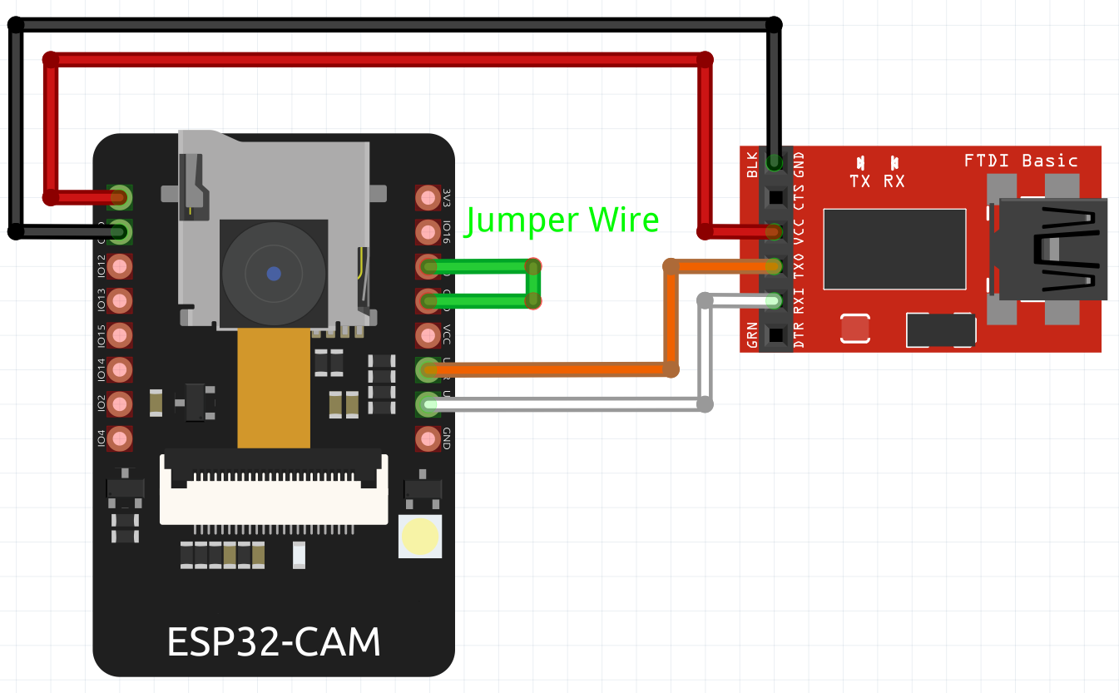

Step 4: Click on the “Upload” button on the top left corner in Arduino IDE to upload the code into the ESP32 board as shown.

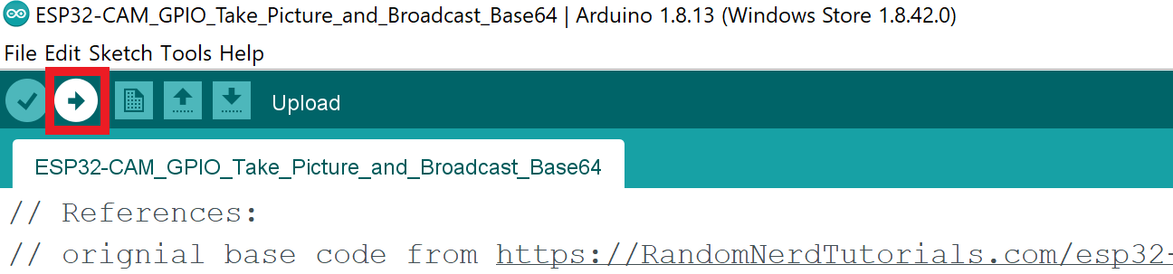

Step 5: Repeat Steps 3 and 4 for each ESP32/ESP32-CAM to upload the respective codes.

Take a Picture using the ESP32-CAM and send to the Raspberry Pi
The TaskScheduler on ESP32-CAM will detect GPIO 16 state every 30 seconds. If GPIO 16 is low (connected to ground) then it will take a picture, convert to base64, broadcast it and the built-in LED will flash to inform the user that a picture has been taken.

Step 1: Start PainlessMeshBoost on the Raspberry Pi by typing “PainlessMeshBoost --log receive > broadcast.txt” on the terminal.

Step 2: Power up the ESP32-CAM and the 2 ESP32 boards. Wait for at least 1 minute for it to initialise and connect to the Mesh Network.

Step 3: Using the jumper wires on the ESP32-CAM, connect GPIO 16 to ground as shown below to trigger the mechanism to take a picture.

Do note that GPIO 16 is the pin directly above GPIO 0, the pin connected to ground when uploading code onto it in Arduino IDE.

The ESP32-CAM will produce a flash once a picture has been taken, remove the jumper wire when this happens.
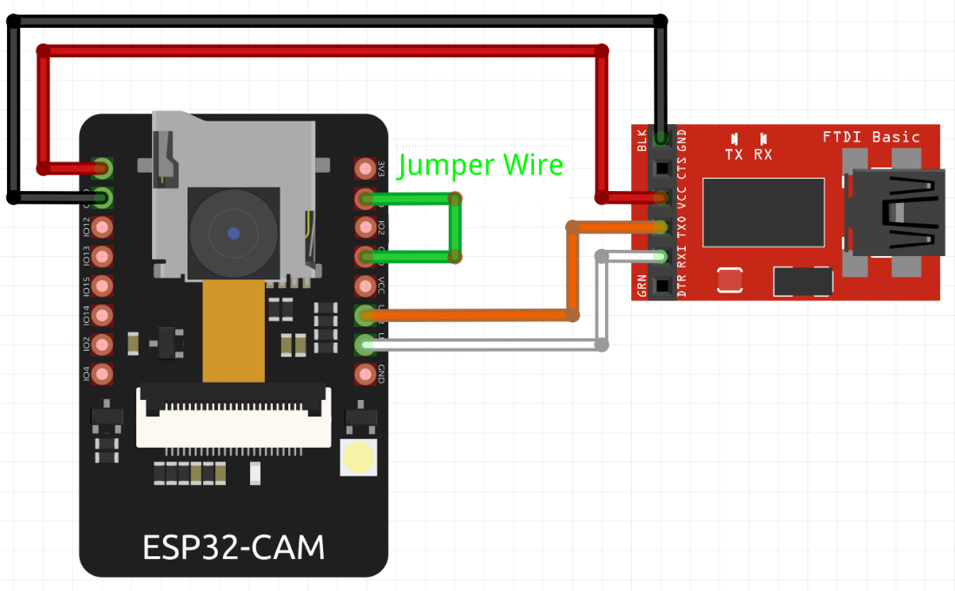

Step 4: End the process on the Raspberry Pi terminal that was running “PainlessMeshBoost --log receive > broadcast.txt” by pressing Ctrl – C after the flash appears on the ESP32-CAM.

Step 5: Open the broadcast.txt file and check that there is only 1 base64 variable inside

Only 1 Base64 can be inside the text file as the Python regex cannot tell how many different Base64 variables there are which can lead to issues with decoding. Hence, it should only have 1 set of Base64 variable in the text file when running the decoding at all times.

Step 6: Run the Python script to extract the base64 variable and decode it into an image, saving it onto the Raspberry Pi server.

Open another terminal, navigate to the directory where the previously downloaded python script is saved and type “python3 decode_and_save_image.py” to run the script.

It will decode the image and save it as decoded_image.jpg in the /home/pi directory. Once it is saved inside the directory, open it to view the image.

References and Additional Reading Materials
ESP32 PainlessMesh
https://github.com/gmag11/painlessMesh
https://randomnerdtutorials.com/esp-mesh-esp32-esp8266-painlessmesh/
https://gitlab.com/painlessMesh/painlessMesh/-/wikis/home
https://gitlab.com/painlessMesh/painlessMesh/-/wikis/mesh-protocol
https://gitlab.com/painlessMesh/painlessMesh/-/wikis/api

ESP32-CAM Photo-Taking
https://RandomNerdTutorials.com/esp32-cam-take-photo-save-microsd-card
https://www.survivingwithandroid.com/esp32-cam-image-classification-machine-learning/

ESP32 GPIO Digital Input
https://microcontrollerslab.com/push-button-esp32-gpio-digital-input/

ESP32 TaskScheduler
https://github.com/arkhipenko/TaskScheduler/blob/master/keywords.txt

Raspberry Pi Python Script
https://regex101.com/r/lHxPKP/1/
https://stackoverflow.com/questions/33487243/find-decode-and-replace-all-base64-values-in-text-file

